How To Use GIT

Step 1. Create Repository on web browser

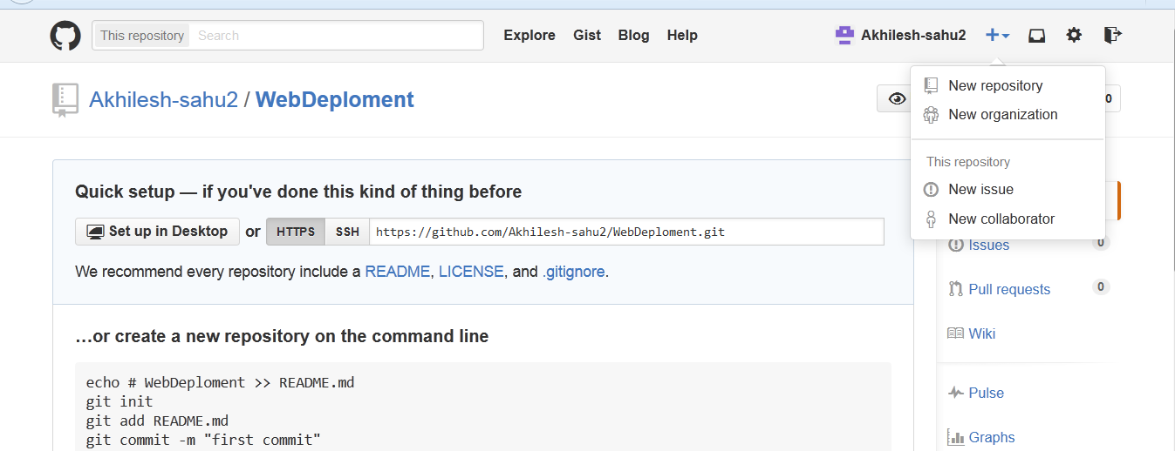

Clone Ur Repository Local through STS Eclipse